BUDGETS: WORKING WITH RADIOBUTONS, CHECKBOXES, PANELS AND PRINTING.
1. Description of the program.
We are going to create a program with a user interface as follows:

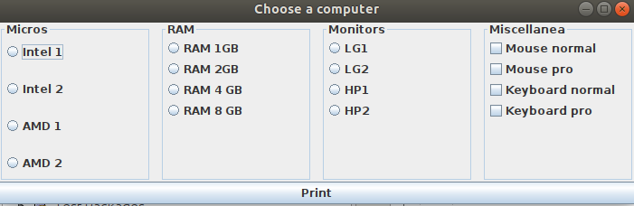
It is about the user choosing which micro, RAM and monitor they want, in addition to the "various" components that they can select, from none to all, since they are checkboxes.
When the Print button is pressed, a print will be made with one line for each chosen product as well as its price and the total amount.
We will now see the aspects that we have not yet studied or those that present some difficulty. At no time are guidelines established on what packages or classes to create, nor what the code should be, nor is there any design pattern established. That is in your hands.
2. Construction of the interface.
The interface in this example is not a problem. We know how to work with the necessary elements. The only thing we have not seen is how to make the border effect and title of the panels. To make this user interface, at least four JPanels have been added, but with a border and a title. We had not seen this. But it is very simple to do. For example to create the "Micros" panel we will use the following code:

TitledBorder title;
title = BorderFactory.createTitledBorder ("Micros");
panel2.setBorder (title);
This will cause the panel to have a border and caption text.
The rest of the elements do not present any inconvenience and I suppose that it will not be difficult for you to do.

3. Data structures.

You can use those data structures that you consider necessary to carry out the program. It must be taken into account that each of the components must have, in addition to a description ("intel 1", "normal mouse", ...), a price.
It would be appropriate if both the description and the price were in some kind of data structure that were easy to access and relate the description to the price.
You can use arrays, arrays, objects, arraysList, etc. As an example, and to simplify a lot, you could create a string matrix for each type of component. For example, in the case of microphones:

String [] [] micros = {{"Intel 1", "300"}, {"Intel 2", "350"}, {"AMD 1", "200"}, {"AMD 2", "250" }};

In such a way that we would have the description of the product along with its price.
At the time of creating the user interface, it would be appropriate to obtain the text of the radiobuttons and the chechboxes of these data structures, so that later it would be easy to change both the descriptions and the prices.
This is the most primitive data structure suggestion. You can do it this way or in a more elaborate way, using classes, collections or even obtaining data from files or databases.

4. Checking the elements selected by the user.
A possible method to check which chekboxes and radiobutons the user has selected could be using some properties of the JPanels. Of course there are more methods to do this and any one works, because it is about you doing the exercise using your methods and tools.
The one I propose is the following: when the user clicks on the button, the selected elements must be checked in the button's listener, using the panel. Panels have a method that allows us to obtain the elements that have been added to the panel as if it were a vector. For example for the case of the micros panel:

for (int x = 0; x <panel2.getComponentCount (); x ++) {
JRadioButton rb = (JRadioButton) panel2.getComponent (x);
if (rb.isSelected ()) {// If the item has been selected
// build text string to print later, in line break format, for example:
printString = rb.getText () + “\ n”;
// this is a very simple example and surely needs to be more worked to collect
// also the price in string Print and add this price to show the text on the print
}
}

5. Print user selection.

There are various methods for printing in java. The easiest to use is based on the use of the print method of the classes that inherit from JTextComponent, that is, JTextField and JTextArea.
This method causes a print to be made of the text contained within the element. We will use a JTextArea field because it allows the use of line breaks. Its use is very simple. For example:

try {// is done with try as printing can generate errors
JTextArea text = new JTextArea ();
text.append ("line 1 \ n"); // with line break: \ n
text.append ("line 2 \ n");
boolean ok = text.print ();
if (ok) {
System.out.println ("All good");
} else {
System.out.println ("Operation Canceled");
}
} catch (Exception e) {
e.printStackTrace ();
}

6. Suggestions for carrying out the program.

- It is important that you start the program and finish it by yourself. As I mentioned on another occasion, it is a good practice for the exam that will be soon. You already know the necessary elements to do it.
- This document expresses ideas on how the data structures can be used. It is the most basic thing that can be done. I encourage you to use alternative structures.
- It is not essential, nor will I consider it as a negative thing, to use MVC. I think it is important to get used to this work pattern since it is very widespread. But it is up to you. If you use it, I will consider it positively, but if you do not, I will not consider it negatively.
- I will also leave next to this topic a NetBeans project called PC Budgets. It is NOT the complete project, it is a start to carry out the exercise, a guide for those who do not know how to start. It is done using vectors and without MVC, which would not be the normal way I would try to do it. My recommendation is that you do not use it and make an effort to start it yourself.
- IMPORTANT: when you call the print method of the JTextArea object, a call to print will be generated. It is necessary to install a PDF printer (if you do not already have it), in this way the prints are made on a pdf document and we will be able to verify what we are really printing.

